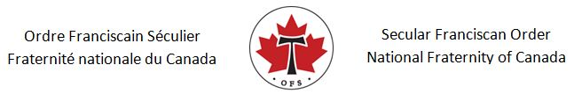
Date

The Honourable Marco Mendicino, P.C., M.P.
Minister of Public Safety
House of Commons
Ottawa, ON K1A 0A6

Dear Minister Mendicino,

As members of the Secular Franciscan Order (OFS), we follow a way of life established by Saint Francis of Assisi and are committed to being bearers of peace in the world. On behalf of the OFS National Fraternity of Canada, I am writing to voice our support for the efforts of the Government Canada in bringing forward Bill C-21 to strengthen our nation’s current gun control laws.

Although we recognize the importance of this bill, we also believe that there is much more work to be done to keep our communities safe. Many of the crimes in Canada are committed with weapons obtained from the United States through illegal means. We therefore support further policing and border controls on guns which are smuggled into Canada from the U.S. through organized crime and other means.

Finally, we would strongly support a proactive and preventative approach. Public education on this issue is paramount. Community members must be encouraged to report situations where people are known to have weapons and are exhibiting concerning behaviours and uttering threats of violence. Police need to take these reports seriously and investigate them in a timely manner to prevent further tragedies.

Sincerely,

Name, Position and Signature

cc. The Right Honourable Justin Trudeau, Prime Minister of Canada
The Honourable David Lametti, Minister of Justice and Attorney General of Canada

